VAT Guidance – New Standard Rated VAT 20% from the 4th January 2011

We will need to define both an input and an output VAT ledger to accommodate this new rate.

All schools will need to define these ledgers.

Scheme 1 & Scheme 2 Schools (those with a local cheque account) – These new rates will be accommodated within the system VAT reports produced by FMS6. VAT return spreadsheet will be updated by Nahad Choudhury, VAT Accountant and will shortly be available on the Grid, confirmation email to follow.

Schools that operate an Imprest Account. On your Imprest Claims, please ensure you use the appropriate VAT code on all expenditure.

The new rates should only be used where the VAT on any invoices received has been calculated at 20%.
Adding new VAT Ledger Codes

Tools/General Ledger Setup/Ledger Codes (Tab 5)

Click to Add
Select from the drop down menu VAT Input, next

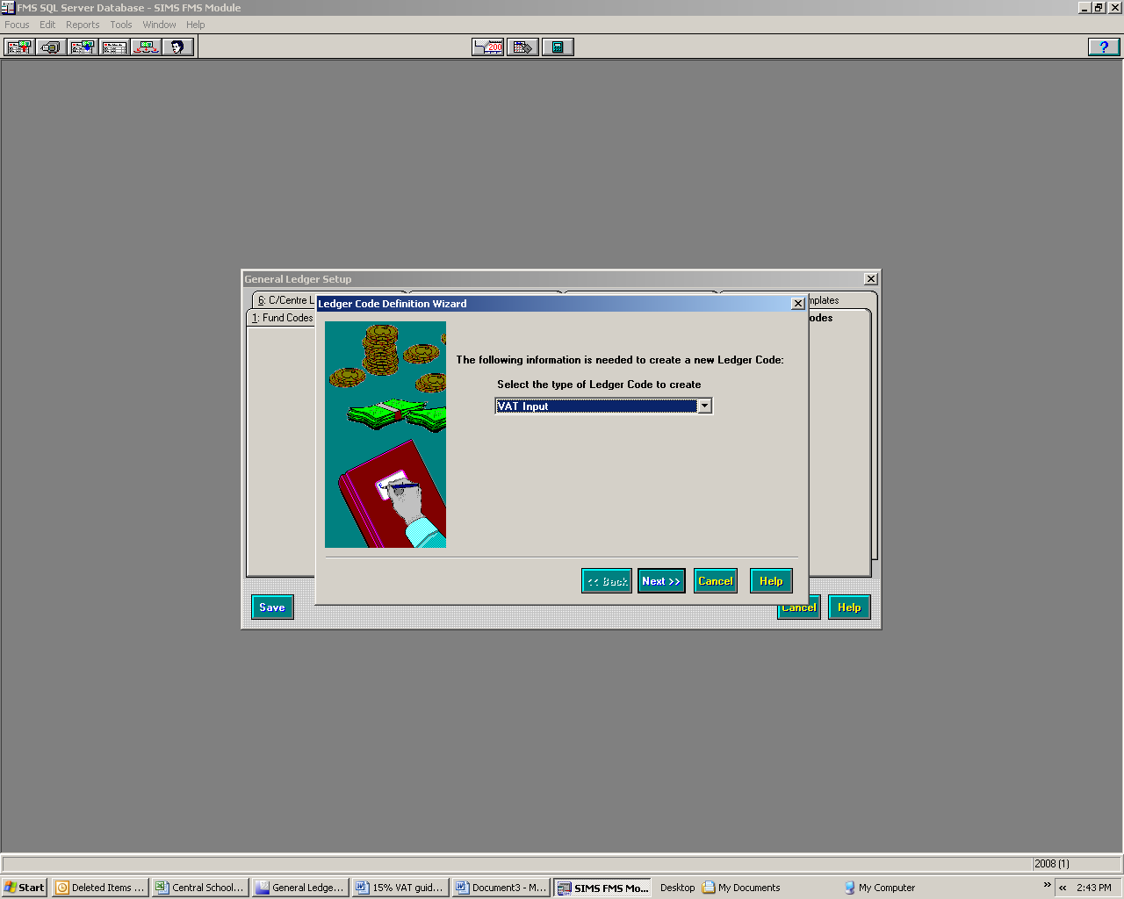

Using the browser, from the drop down menu select the ledger group VAT, Next

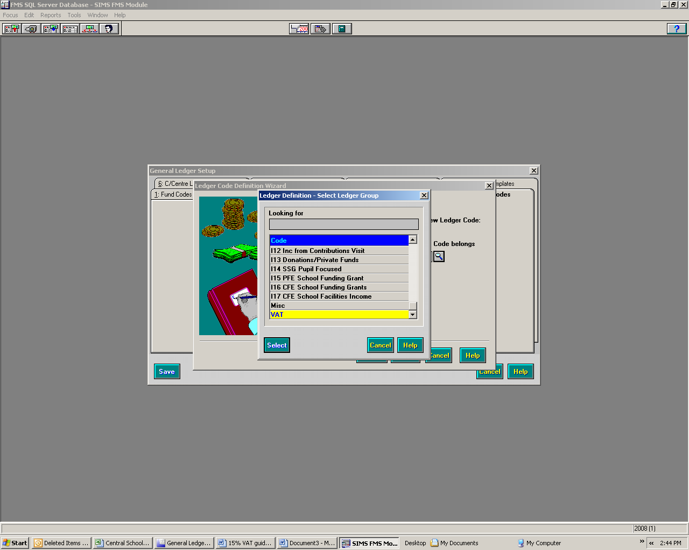

Enter a new code of 8

Enter description 20% Standard rated VAT. Select Finish

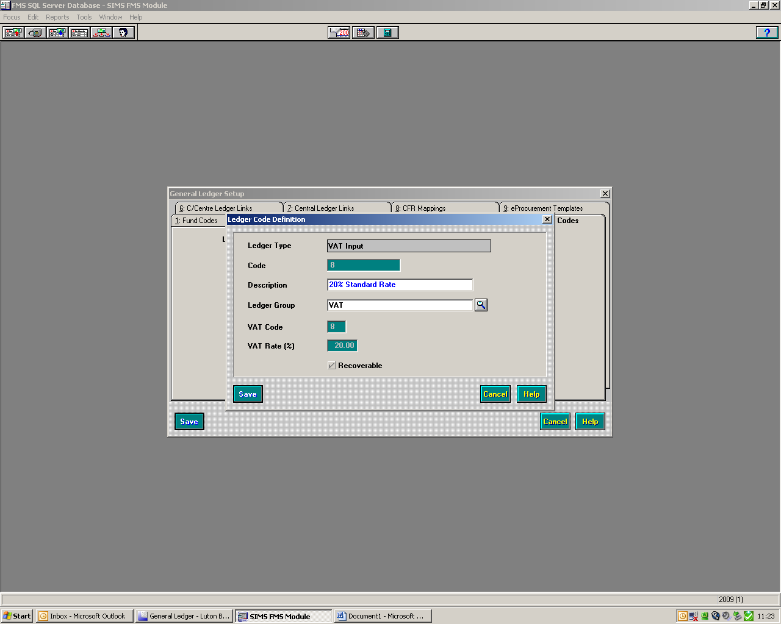

Against VAT Code enter 8
Against VAT Rate (%) enter 20
Ensure the check box Recoverable has been ticked
Save
You will receive a message saying that if you press OK, this action will be unrecoverable. If you are happy with what you have entered, click OK.

Then save again.

Now define the Output ledger.

Tools/General Ledger Setup/Ledger Codes (Tab 5)

Click to Add

Select from the drop down menu VAT Output, next

Using the browser, from the drop down menu select ledger group VAT, next

Enter a new code of N
Enter description 20% Standard Rated Bus Inc, Finish

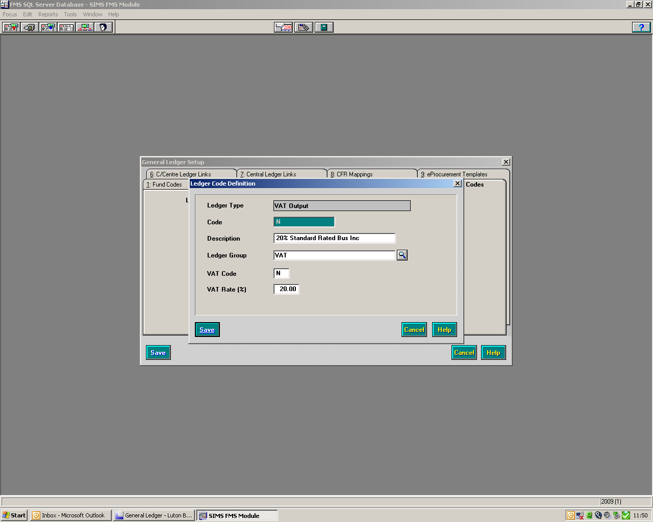
Against VAT code enter N
Against VAT Rate (%) enter 20

Save.
You will receive a message saying that if you press OK, this action will be unrecoverable. If you are happy with what you have entered, click OK.

